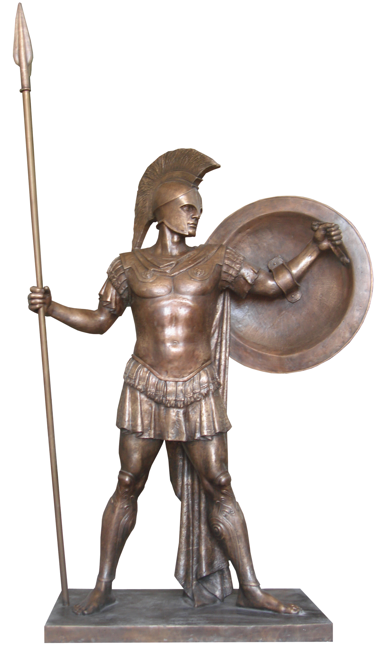
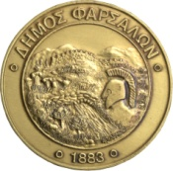

Municipality of Farsala Ephorate of Antiquities of Larissa
2nd International Farsala Conference
"The Homeric Achilles: diachronic reflections in the art and the literature"
Farsala, February 2019

The historical route of the Farsala area in time is long and uninterrupted from the earliest Neolithic period to the present day and the place has been connected with very important moments in the Greek history. At the same time, Pharsalus’ land, the Homeric Fthia, is the birthplace of the most iconic hero of ancient Greece, Achilles.
The Municipality of Farsala, together with the Ephorate of Antiquities of Larissa, organizes from February 7th to 9th 2019 the 2nd International Farsala Conference on "The Homeric Achilles: diachronic reflections in the art and the literature"
The purpose of the scientific meeting is to create, as thorough as possible, a corpus to capture Achilles' stigma in every form of ancient, medieval and modern literature, but also in every form of art (vase - painting, painting, sculpture, miniature) from antiquity to the present day, and on the other hand to record the recent archaeological data of his native land.
The thematic axes concern the following fields:
1. Achilles in the epic poetry and the ancient literature
2. Achilles in the medieval, Greek and foreign literature
3. Achilles in the modern, Greek and foreign literature
4. Achilles in ancient vase - painting
5. Achilles in painting (from antiquity to today)
6. Achilles in sculpture (from antiquity to today)
7. Achilles in miniature or traditional handicraft (from antiquity to the present time)
8. Historical and archaeological data for the area of ​​ancient Fthia
9. Survivors - Uses of the name of Achilles in modern times
10. Achilles in modern fiction
11. Achilles as a brand name
The relevant Ephotates of Antiquities, Universities in Greece and abroad, Research Centers and Institutes, Foreign Archaeological Schools and researchers are invited to participate.
The duration of the notices shall not exceed 15’ minutes. The languages ​​of the conference will be Greek and English. At the same time, it is possible to present works in the form of posters.
The Municipality of Farsala will publish the volume of the Conference within six months.
If you wish to participate, please fill in the attached application form and send it to the Organizing Committee no later than 31.10.2018, with the title of your announcement and a short abstract in Greek or English for publication the abstracts’ book.
Farsala, June 1, 2018
THE ORGANIZATIONAL COMMITTEE
Municipality of Farsala
Karachalios Aristomenis, Mayor of Farsala - President of the Congress
Mpampanikas Dimitris, Deputy Mayor of Farsala
Derlos Konstantinos, President of OPAKPA of the Municipality of Farsala
Noula Vassiliki, Special Associate of the Mayor of Farsala, Archaeologist
Ephorate of Antiquities of Larissa
Dr. Sdrolia Stavroula, Archaeologist, Head of the Ephorate of Antiquities of Larissa.
Dr. Toufexis Giorgos, Archaeologist, Deputy Head of the Ephorate of Antiquities of Larissa.
Karapanou Sophia, Archaeologist, Ephorate of Antiquities of Larissa.

THE SCIENTIFIC COMMITTEE
(the list is still open)
Dr. Anagnostopoulos Vasileios, Emeritus Professor, University of Thessaly
Karapanou Sophia, Archaeologist, Ephorate of Antiquities of Larissa.
Dr. La Torre Gioacchino Francesco, Professore Ordinariodi Archeologia Classica Dipartimento di Civiltà Antiche e Moderne dell’Università degli Studi di Messina
Noula Vassiliki, Special Associate of the Mayor of Farsala, Archaeologist
Dr. Sdrolia Stavroula, Archaeologist, Head of the Ephorate of Antiquities of Larissa.
Dr. Tselekas Panagiotis, Assistant Professor in Classical Archaeology and Numismatics, School of History and Archaeology, Faculty of Philosophy, Aristotle University of Thessaloniki

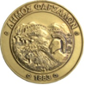
Municipality of Farsala Ephorate of Antiquities of Larissa
2nd International Farsala Conference
"The Homeric Achilles: diachronic reflections in the art and the literature"
Farsala, February 2019
DECLARATION OF PARTICIPATION

NAME:
SURNAME:
ADDRESS:
PHONE:
FAX:
E-MAIL:
TITLE OF ANNOUNCEMENT:
SIGNATURE:
DATE:

THE ABSTRACT
Instructions:
• The abstract can be submitted in Greek or English.
• For the submission of the abstract, authors should use the model provided by the conference organizing committee.
• The extent of the clear text of the abstract should be from 200 to 300 words. The page margins should be set to 2.5 cm (top-down and left-right) in Times New Roman font 11 points for the entire text except for the title to be used Bold 12-point font in capital letters .
• The summary should include:
- the title,
- 3-5 keywords, and
- 3-10 basic bibliographic references
• It should be noted that a participant can not have more than two papers at the Conference.

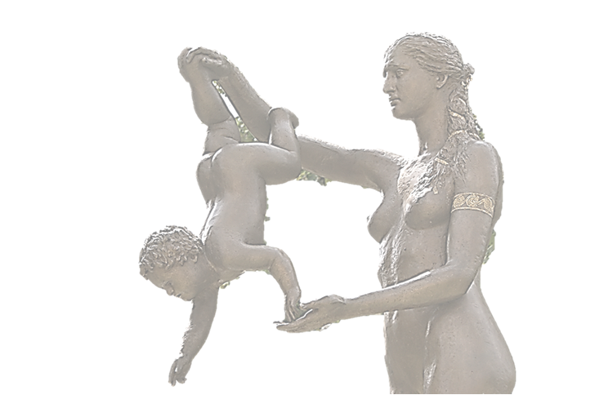

By requesting to send either forms to:
Municipality of Farsala
3 Patroklou str.
40300, Farsala
(in view: Vassiliki Noula)
Tel.: +0030 24913 50118, +0030 6932330438
FAX: +0030 24910 23914
Either online at the email address:
vasso.noula@gmail.com

