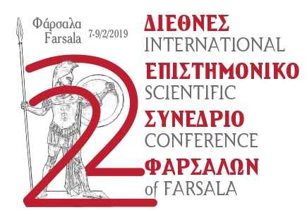

AUTHOR GUIDELINES FOR THE ANNALS

The Municipality of Farsala and the Organazing Committee of the 2nd International Conference of Farsala having successfully completed the workings of the Conference wish to extend warm thanks to all the delegetes for their participation, as well as their attribute to the completion of the workings and the high scientific standards throughout the whole project.

We are naturally transcending to the following phase in which the Municipality of Farsala is going to come true to its commitment of publishing the Annals of the Conference. In order for the publication to take place it is imperative to be acted upon before the imminent Municipal elections, i.e. before May 2019. Therefore, the participants are requested to be punctual regarding the date of delivery of their texts as well as the general instructions they adhere to:

- The final deadline for paper submission is March 26th, 2019.

- Manuscripts must be in digital format [preferably in MS-WORD]. Each submission should include a printed copy and a CD (avoid floppy disks).

- Manuscripts should not exceed 4,500 words (with an additional 10% tolerance), including references [footnotes]. To this extent is not counting the references that are not subject to any restriction.

- Illustrations are limited to the absolutely necessary pictures and drawings [highest limit 15] that can be submitted as hard copies or digital [CD — not through e-mail]. Digital images resolution must be of 300dpi at least. ATTENTION: It is preferable to submit the original drawings [or high quality photocopies] as well as slides or black-and-white photographs that will be digitalized by the editors, rather than problematic digital images [of low resolution, small dimensions].

- Numbering of drawings, photographs, tables, etc, must be unified as “Figures”. Illustration subtitles must be submitted in a separate page.

- Please send also an abstract in a different language than the paper [up to half a page].

- Editors of the Annals are Aris Karachalios and Vassiliki K. Noula.

- Manuscripts must be submitted to the address: Municipality of Farsala, 3 Patroclus Str., 40300, Farsala, Greece (Consideration: Mrs. Vasso K. Noula), tel: +30-24913-50118, mob:+306932330438, FAX: +30-24910-23914, under the denotation “2nd International Scientific Conference”. Texts should also be sent via e-mail to vasso.noula@gmail.com

- The Annals are to be published within 2019, before August.

EDITING GUIDELINES

- Page with text of approximately 30-35 lines, letters of size 12 and line space of 1.5 [15cm in width].

- All titles must be written in CAPITAL letters, ancient texts in italics.

- References must be footnotes [letters of size 10] and must include the author’s surname, the year of edition and the number of the page (i.e. Stahlin 1924, 23).

- At the end of each paper there must be a detailed bibliography list, where references/footnotes are cited. Should there be more than one work of an author in the same year, a, b, c etc., the date must be followed [i.e. Arvanitopoulos 1911a, 1911b, 1911c...]. In case of collective studies reference must include all surnames [i.e. Agouridis – Zigouri – Rontiri 1991, 31].

- Abbreviations follow the accustomed system [i.e. BSA or AJA]

Manuscripts that will not follow the above guidelines will be returned to the authors.

Farsala, February 18, 2019

On behalf of the Organizing Committee

The Farsala Mayor's Special Counsillor – Archaeologist

Vassiliki K. Noula

